18.9.2022

I am making Ludo Game! Finally! I wanted to do this project in quite some time for now, but didn`t really have much free time to actually start doing it (and feeling lazy sometimes ha!). So I can surely tell that I`m somewhat excited about this project. So, without further chatting, let`s start!

Yesterday I decided to jumpstart this. I was thinking about all techologies that I`ll use in this one. And I mapped everything out. More on this and initial plan will be written in the README.md file in the project repository.

I will first do the UI for this game (which shouldn`t really be that complicated) and then I will do the backend and DBMS and connect all the necessary dots between them.

So let`s start by actually doing something. In the meanwhile, project has been initialized localy on my PC and has the code repository on my GitHub. All further savings will be saved there.

1. Initialize the project

Project initialization starts with opening Visual Studio Code Editor (just VS Code in continuation). Creating one empty HTML, CSS and JS file.

HTML file is called app.html, because the script will contain all markup stuff that will be used in the game and it will be used as a central point of the game and it`s UI.

CSS file is called board.css, because it will contain styles relative to the game board.

JS file is called app.js, because it will be used for central gaming loop logic.

All files don`t have any special directory in which they should reside for now, they all have one relative path, which will change in the future as the project grows.

1. Game board

The game board I will use will have the standard Ludo Game board, without anything fancy added to it, really.

The board is having three parts that are repeating, which are: player start area (which contains 4 player rings), board squares (which some of them will have different features and styles) and central triangle thing (I cannot find any better name for this one, it`s just a design without any real funcionality, really).

Since those three parts are repeating through the board, I will code each one of them once and have them repeat in app.html, just with different styles for each player.

1. Game board analysis

As shown on the image, there are exactly 3 main patterns (as said earlier) that are repeating.

We can see that all the board elements can be translated to the size of the one board square on which player moves. So, let`s consider that the one board square have a width of 50px and a height of the 50px (they are equal, because it`s a cube after all). We can see from the image that player start area has a width and the height of six of the board cubes, and the central triangle thing has a width and the height of three of the board cubes. So, player start area has the size of 300 x 300, central triangle thing has the size of the 150 x 150, and one group of the board squares has the size of 300 x 150 (or 150 x 300, depends on the fact are they rotated or not).

From that fact, we can conclude that our board size will be 750 x 750, after we add up all the sizes of these repeating board elements.

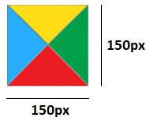

1. Creating game board

We have to open app.html and do all the board markup elements.

The boards will contain one major div container, which will serve as a wrapper. All of the HTML elements will be of type <div></div>.

The board will have 3 different rows, and the way the rows will be mapped is:

1. player start area – board squares – player start area
2. board squares (rotated on the Z axis) – center triangle thing – board squares (rotated on the Z axis)
3. player start area – board squares – player start area

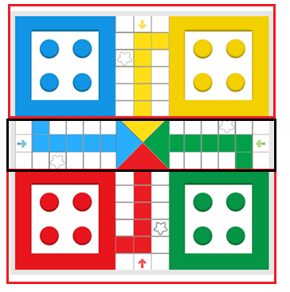

Let`s set the player start area, and four player rings, in which our players will reside before they are called for the game:

Player rings are put inside of the player start area, because we will style them relatively to that point.

Next, we are setting the a wrapper around around player start area:

Next, let`s set the board squares, which will be just squares with the same size that are repeting in the pattern, and set their wrapper, which is called „board squares“ :

Next, we have to set the center triangle thing, and the following code will do the job:



(that`s actually it for the markup of this one xD)

So now that we are having all of the three essential elements created, let`s create different rows

with them, as shown on the picture above:

First row:

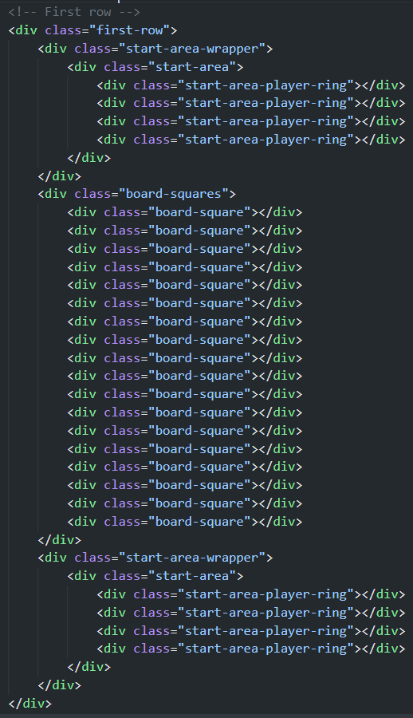

Second row:

Third row:

Third row is essentially without any difference at all from the first row.

I like to add comments for better navigation in editor and better reading, but they are not essential.

After we completed markup, let`s style those elements next. We are going to open board.css script and write all the styles there.

When I create styling, first I like to see the repeating patterns. If there are any repeating patterns in the styles, I usually create standalone variable for that. For example, if I see that some color is repeating, I will extract that value in :root pseudoclass, and use it under that name in the file. With that practice, we are making sure that if we are changing the value of that variable in the future, we only have to change it`s value in one place, and not anywhere else in the code. That way the code is cleaner and more maintainable (as well as we`re saving some time to ourselves).

Going from that, I extracted all the color values used in this game in :root pseudoclass:

In the future, of course this code will be changed, but for now it is what it is.

Next, I reseted all the values on the body element, so that I don`t have to deal with any sort of that later in the project:

DISCLAIMER: all of the files in this entire project will reside in the SASS project files after I decide to create them in the future. For now, and always as I`m doing projects, I like to keep things simple at the beginning, and adding all the complexity later.

Using SASS is making the CSS so much more organized and clean. But more of that later in the process. For now, I am keeping things as simple as possible.

Next, let`s style the player start area:

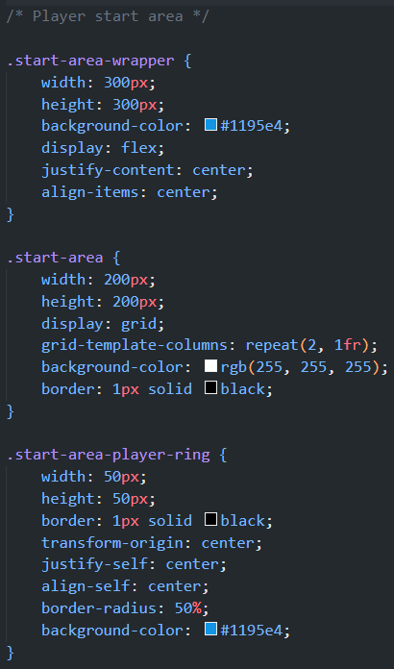

The start area is essentialy the white square on the board which holds four of the player rings, for each player of course. The width should be 200 x 200, because the colorized wrapper around is 100 x 100 of the size, so that both can add up to 300 x 300. The start area is displayed as a grid container, because it contains four rigidly and 2D-spreaded player rings. With grid-template-columns property, we can determine how we want player rings to be spreaded --> in this case we want to repeat 2 player rings in each row, and as we got 4 of them, this gird property will put two of the player rings in one row, and two of the player rings on the next row. Background color and border properties are self explanatory.

The start area wrapper has width and height of 300px, and it located under the start area. You could argue that I could have used padding with size of 100 x 100 on the start area, and that alone would cancel the start area wrapper, but I just prefer this way.

The start area player ring is 50 x 50 of the size, or the same as the board squares. They are essentialy board squares which are turned in the rings (or circles) with border-radius property set to 50%. Since they are the children of the start area, we need to give them some vertical centering (align-self: center) and some horizontal centering (justify-self: center), so that they can be dead-centered inside of their each grid container.